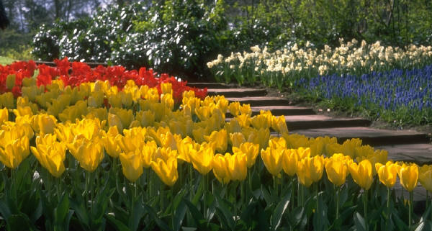

7:00 Open
Call to Order
7:30 Citizen Comments
Approval of Minutes – January 11, February 15 & 22, April 3 & 18
Appointments

7:35 Brian Gillis, Columbia Gas, Paul Foulsham, Highway Surveyor- Columbia Gas request for a road opening permit starting at Norwell/Hanover Town Line east on Main Street 7,320 ft to 322 Main Street (Sparrell School) including all intersections 100 ft eat way.

Old Business
New Business

- Appointment Process

- Tax Relief

- Future Meetings Discussion

Upcoming Meetings
Announcements
Adjournment
Executive Session

